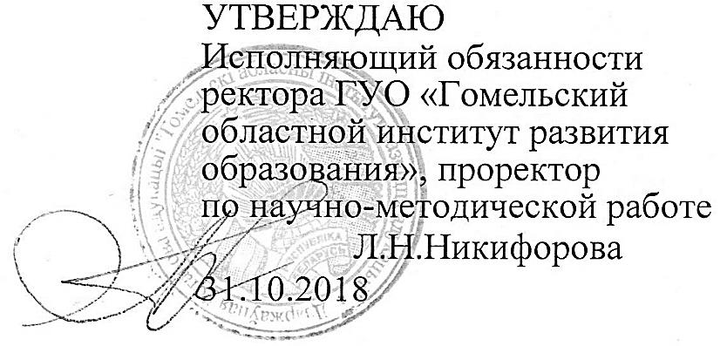
Задания второго этапа республиканской олимпиады
по учебному предмету «Английский язык»
2018/2019 учебный год
X класс

Аудирование
Количество – 34 балла

Listening 1.
You will hear a man called Markus Fischer talking about mooncake, a traditional Asian bakery product. For questions 1 - 10, complete the sentences with a word or short phrase relevant to the audio. (20 points)

Mooncake
Markus was staying in (1) ____________ when he first tried mooncake.
Markus's favourite kind of mooncake has a filling made of (2) _____________.
Markus says that he likes to have (3) _______________with mooncake. Mooncake is popular during the Moon Festival, which last year was held in (4) __________. The mooncake Marcus was given during the festival had the shape of a (5) _____________ on the top.
Markus was surprised to learn that mooncake is rarely made (6) ___________ in China.
The people Markus was staying with received mooncake from their (7) ____________.
His host family gave Markus a mooncake that had a slightly (8) __________ flavour.
Markus was told that, many years ago, people used mooncakes to send (9) _________ to each other.
After people had read what was written on the mooncake, they (10) __________ it.

Listening 2.
You will hear an interview with a woman called Adriana Moretti, who works as a wildlife photographer. For questions 1-7, choose the best answer (А, В or C).
(14 points)

- Why did Adriana want to become a wildlife photographer?
A She enjoyed travelling to remote locations.
В She was very good at taking photos.
С She was interested in animal behaviour.

- Why, according to Adriana, is it easier nowadays to learn how to photograph animals?
A The necessary equipment is cheaper than it used to be.
В It is possible to learn wildlife photography online.
С Cheap international travel means more species can be photographed.

- Why did Adriana feel uncomfortable while she was trying to take photos of birds?
A She was not able to sit down.
В Her feet were getting wet.
С She was being bitten by insects.

- How did Adriana feel when she was trying to photograph the crocodile?
A afraid that it might try to attack her
В worried she may not get the photo she wanted
С increasingly bored with waiting to take the picture

- Adriana has still never taken photos of
A a tiger in India.
В a snow leopard in China.
С a polar bear in Russia.

- What disadvantage does Adriana say her work has?
A She sometimes feels lonely when she is working abroad.
В She doesn't see her family as often as she would like to.
С She always has to go where the agency tells her.

- Adriana believes it is becoming harder to get work as a wildlife photographer because
A so many photos of wildlife are available on the Internet.
В there is a lot of competition for jobs in wildlife photography.
С people are becoming less interested in wildlife.

